Better Outcomes with Alternative Solutions

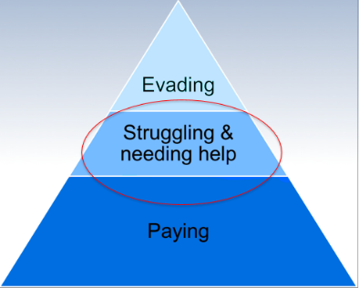
While working with parents and speaking with NCP’s in your case load, the parent identifies that they are struggling with barriers that prevent them from meeting their obligation. You, being the great SEO that you are, immediately think about Alternative Solutions. You provide the website, number, or email and hope that they will contact the Program. Maybe you even see that they did, but it may not have the result you had hoped for. What happened?

What makes someone a good candidate for Alternative Solutions?

Well, there are many elements to success. Let’s take a look at some key points to keep in mind:

Reliable communication.

Parent response to progress status check-ins are vital to success in Alternative Solutions. A communication method is needed for the program to engage parents. We can work with a parent that has email while assisting them in securing a phone. . If you would like to get a Parent started with a Lifeline phone, please visit the database, Statewide Resources-Basic Needs

Their goals, not our goals.

While it may seem like a parent should immediately address employment, they may need to address their housing, legal issues, or mental health and not be ready for employment resources at this time.

100% voluntary.

Experience tells us when a parent feels that they MUST call to avoid adverse enforcement actions or other consequences, they are less likely to engage with us or the resources we may provide.

If you feel that a parent in your caseload could really benefit from participating, have a conversation about what the Program can do for their success if they are to engage. If you are unsure if making a referral will be beneficial, please reach out to the Alternative Solution team. Although a parent may not find success initially, seeds of hope and action have been planted that there is help. We often see these parents enroll in the future.

Experiencing barriers other than routine child support issues.

If a parent is only looking to initiate a Conference Board, license agreement, or a modification, they are generally not eligible and will be advised to connect with you to address their child support specific needs and questions.

It isn’t what they thought.

This happens, sometimes when a parent sees or hears, “need help paying your support?”, they think they have found a program that can literally pay their support, place them in a job, pay for housing or do all the contacting and work for them. Sometimes they withdraw when they find out that isn’t our scope. That is okay!

The elephant in the room.

A parent may not be ready to address the issues like Mental Health and Substance Abuse, which have caused more barriers and make them unable to keep stable housing and employment. If they would like resources to address them, we are happy to provide them. If they are not ready, they can always re-enroll when they are. Upon leaving the Program, if they were able to address any of their barriers that has improved their situation, that is a success.

So what does a typical Alternative Solutions Program parent look like?
- Parent facing barriers. Examples:
  - Employment Needs - Unemployed, under-employed, Limited Employment History
  - Criminal History – Incarceration, Community Supervision, Significant Legal Financial Obligations, and License Suspension
  - Experiencing Homelessness – In Need of Housing Assistance, In Danger of Losing Housing, or Safe Temporary Shelter
  - Education needs – No High School Diploma or GED; Seeking Vocational Training or Secondary Education
  - Health Concerns – Substance Abuse, Mental Health Treatment, Medical or Dental Care

